openSUSE Linux – Installation Baseline

This document describes openSUSE 13.2 OS Linux installation.
To to this you need to boot from bootable openSUSE installation DVD or PXE and choose “Installation”

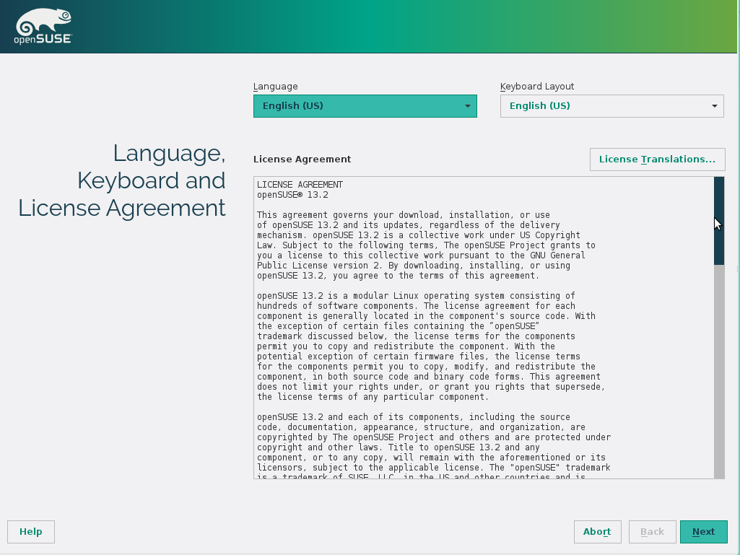

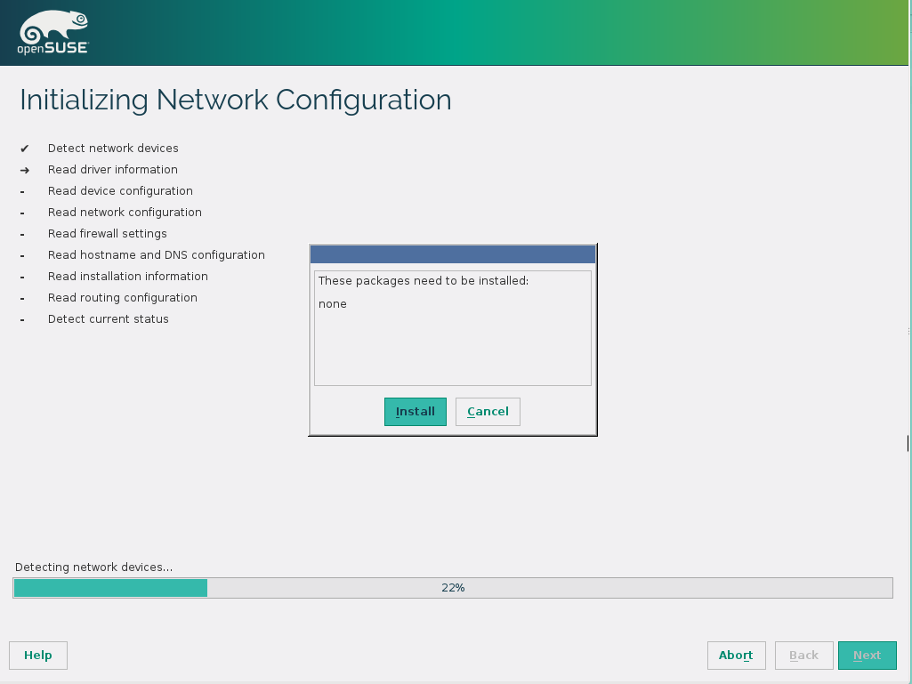

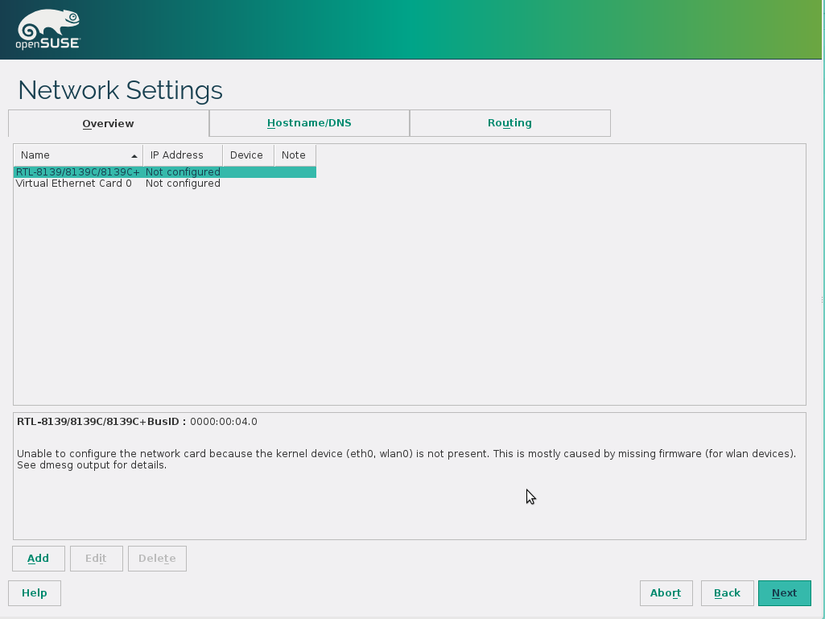

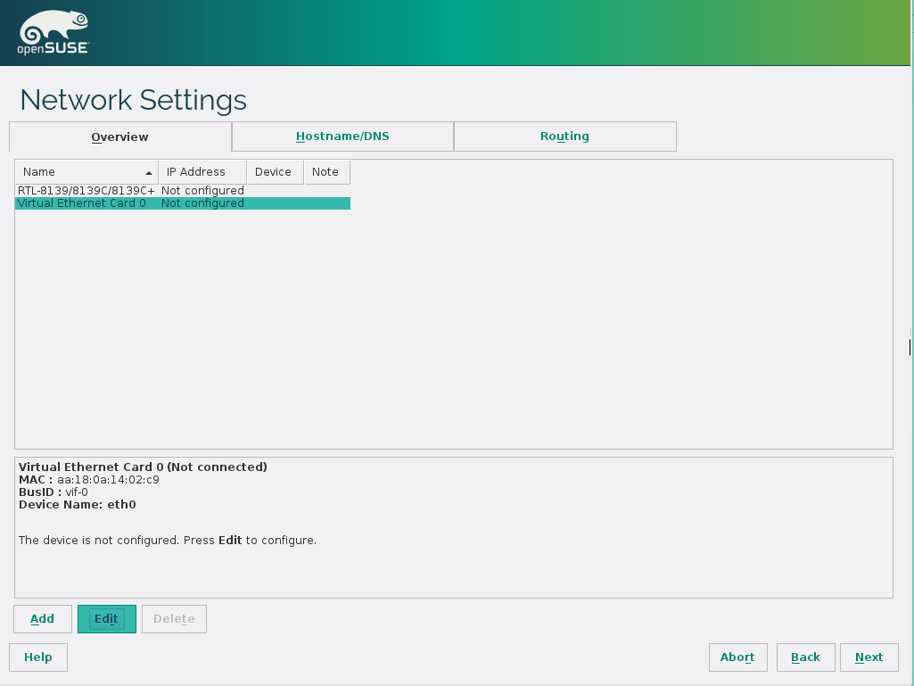

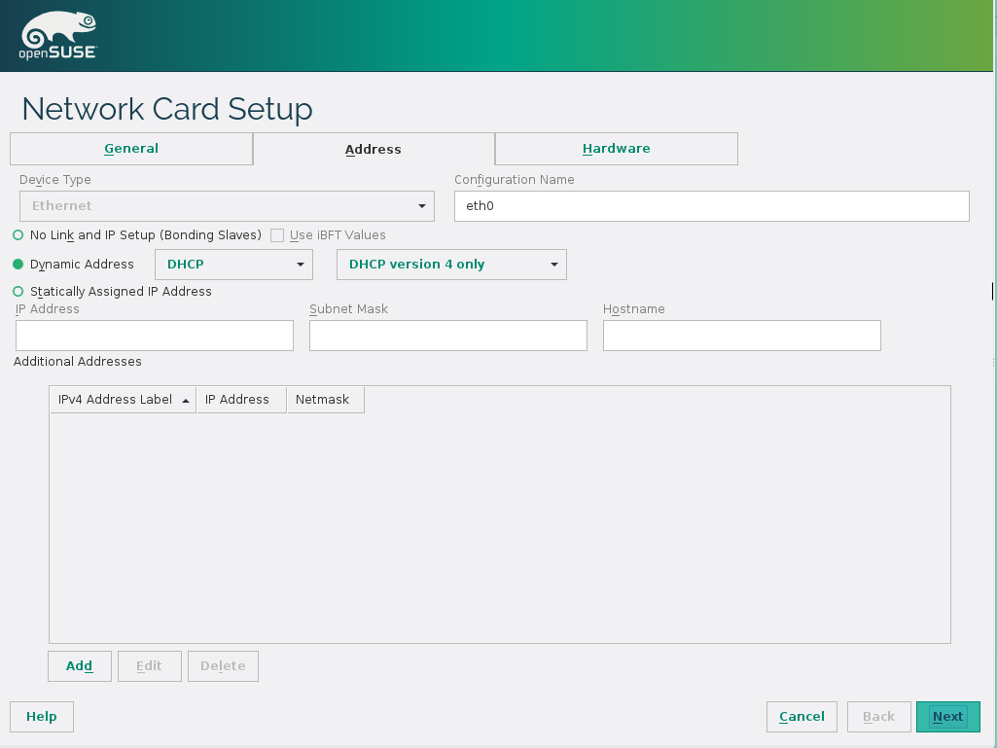

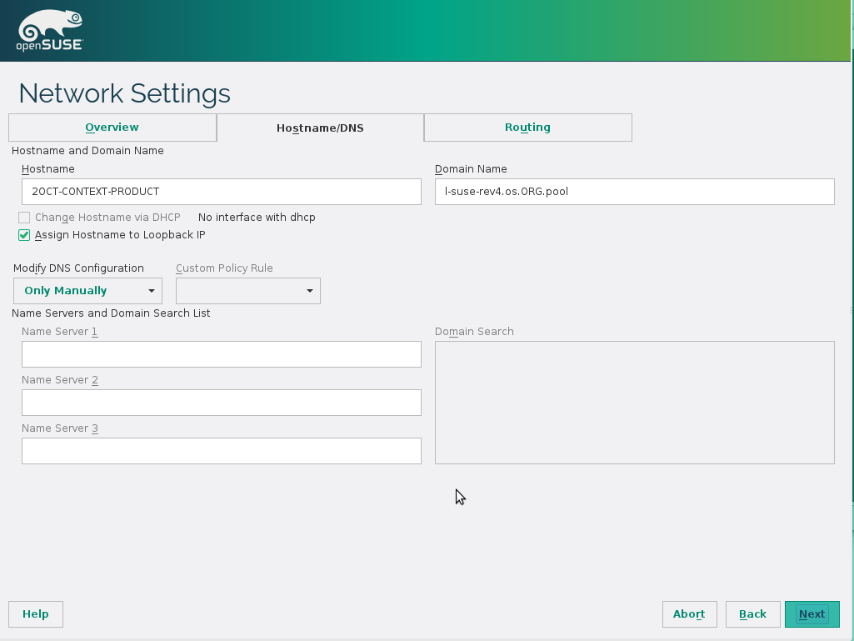
DNS → Automatic
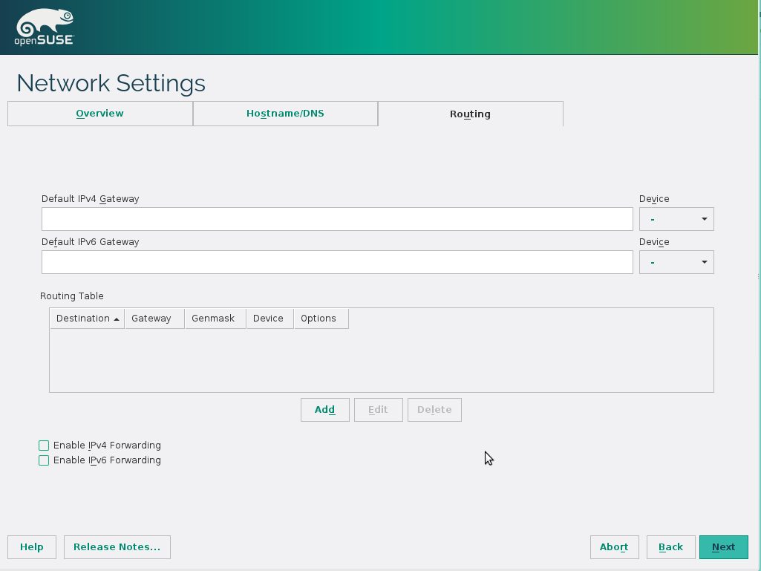

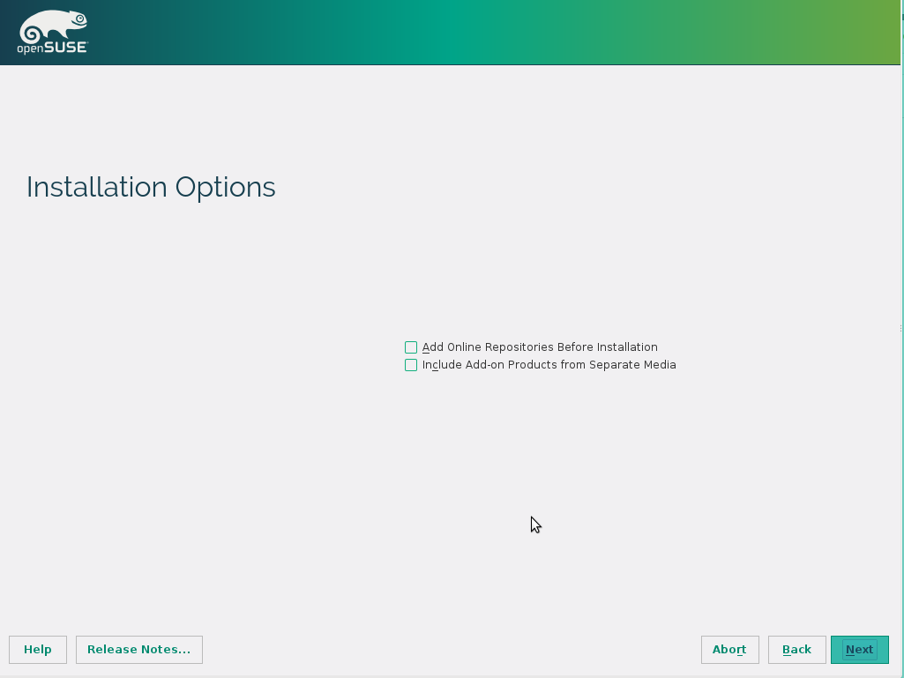

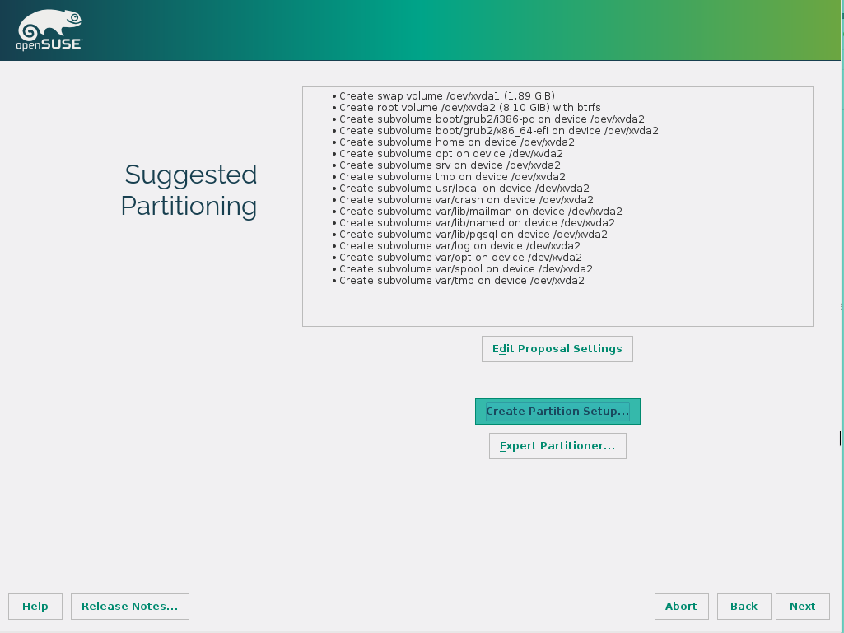

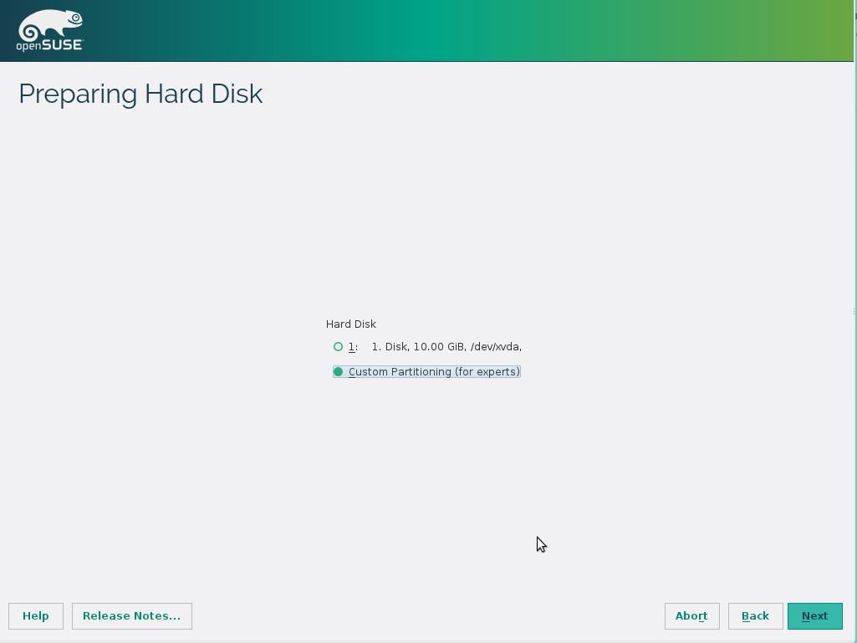

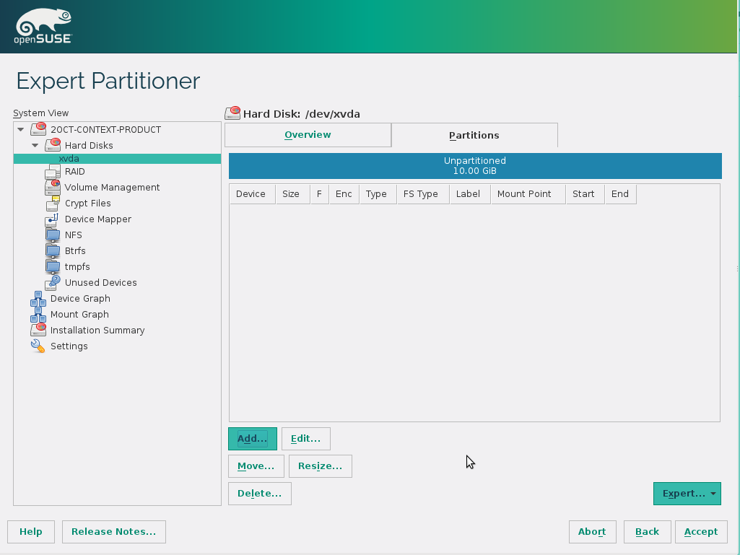

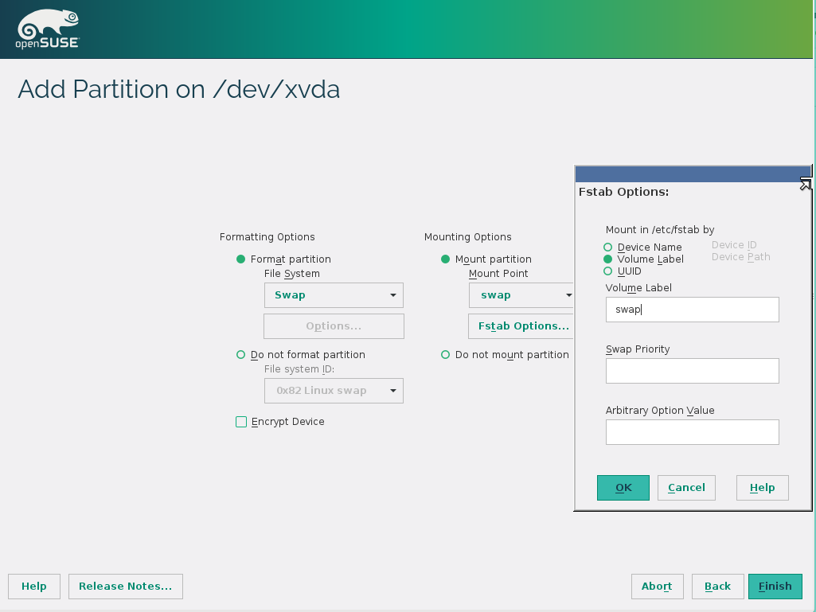

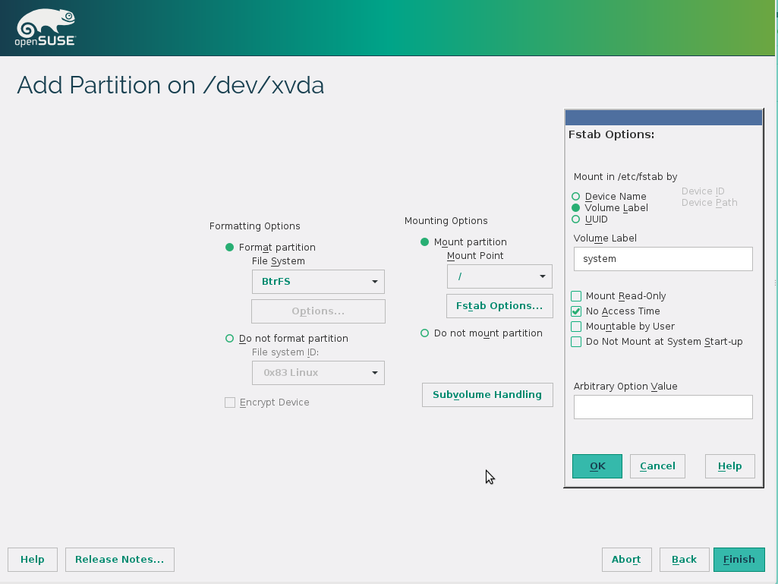

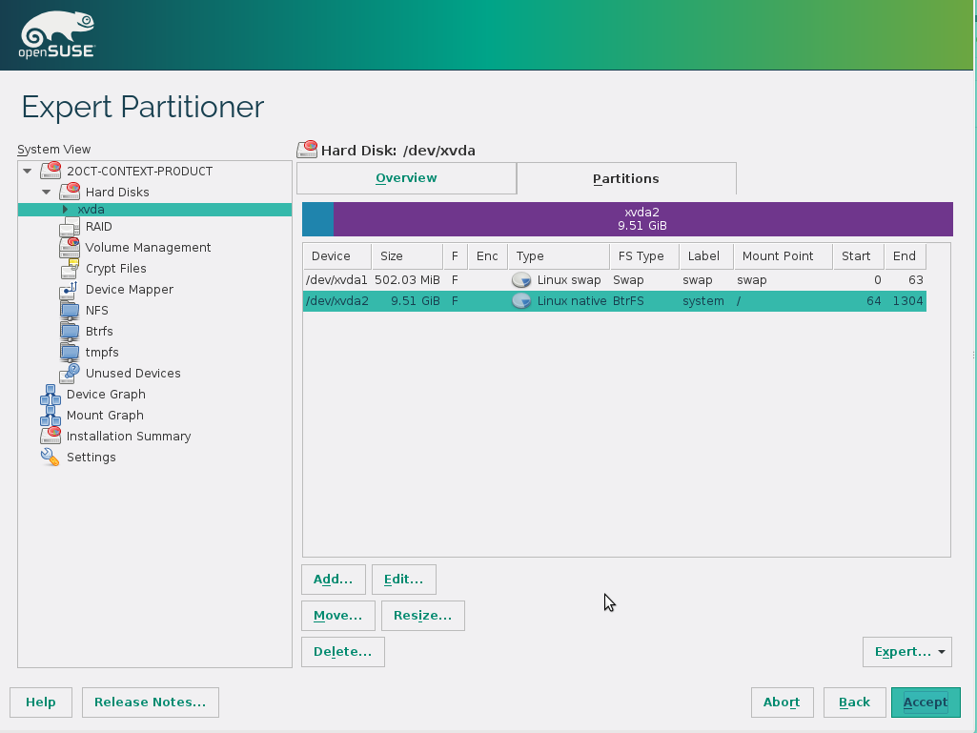

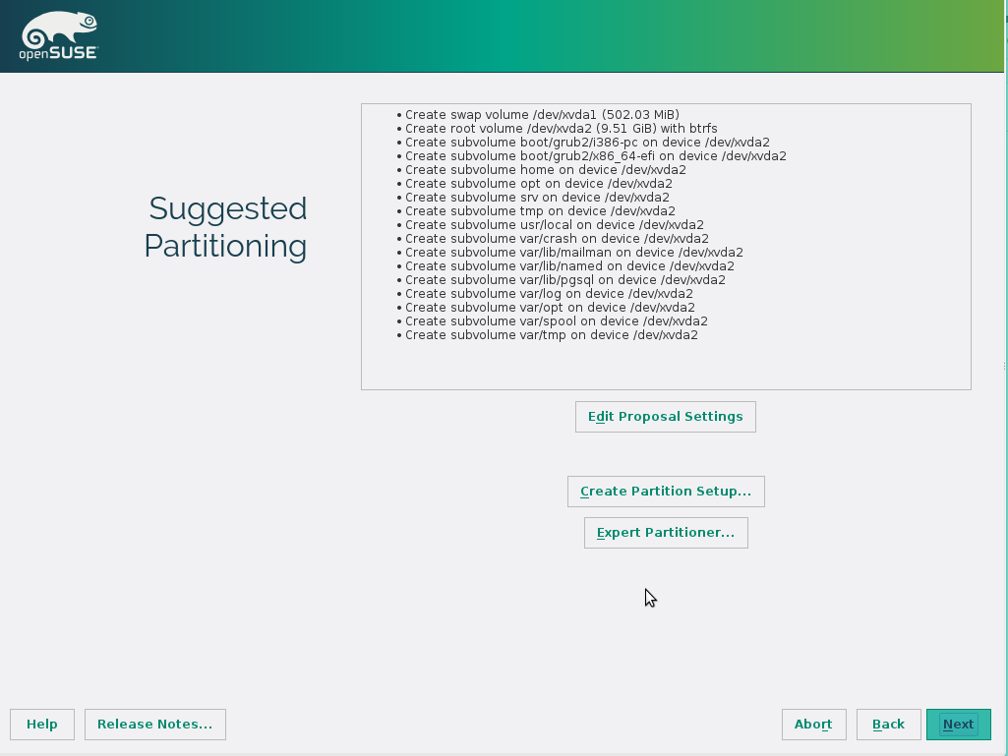

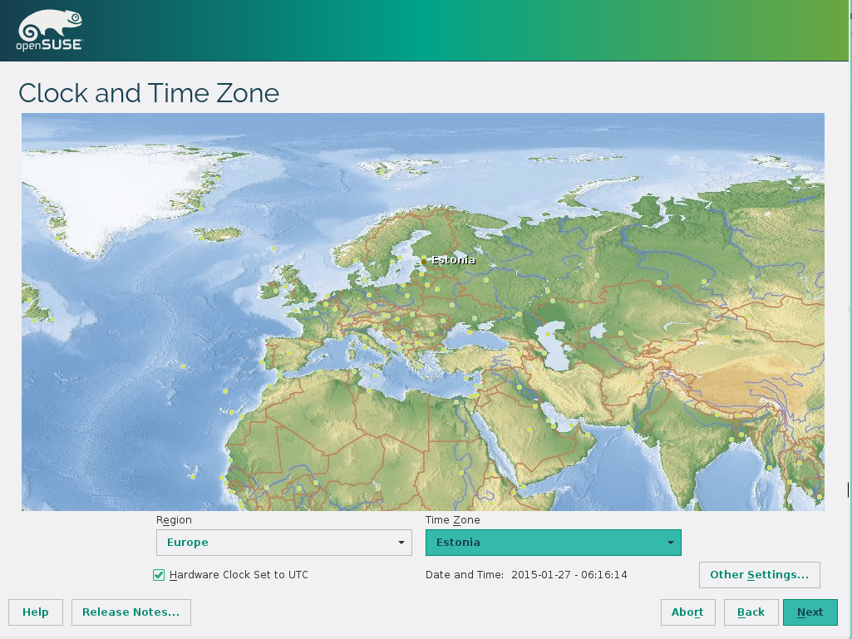

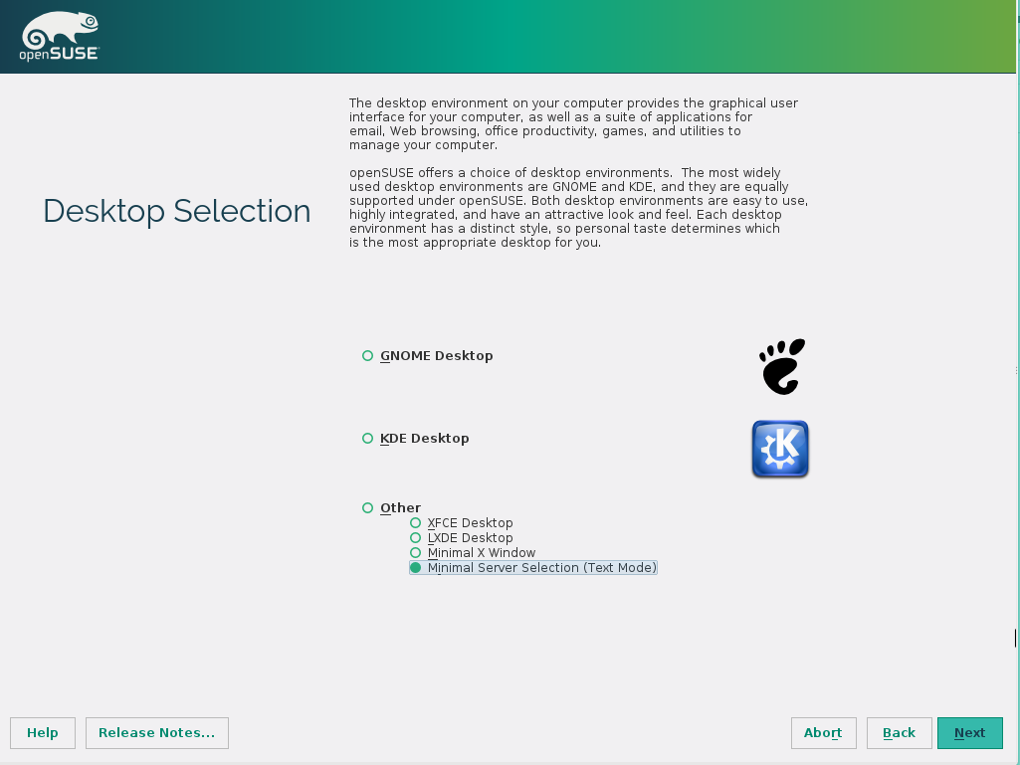

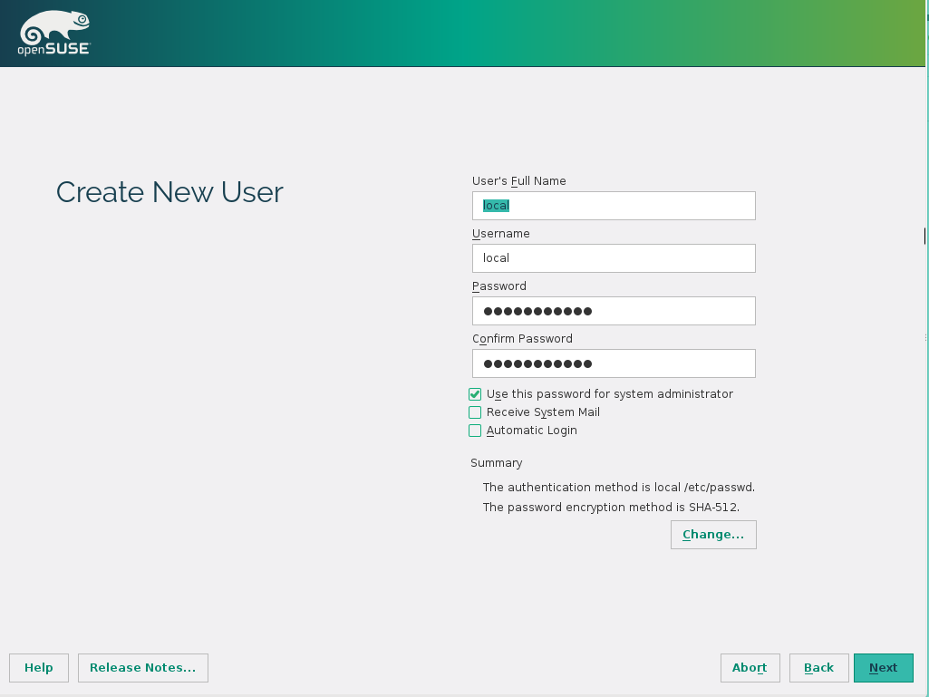

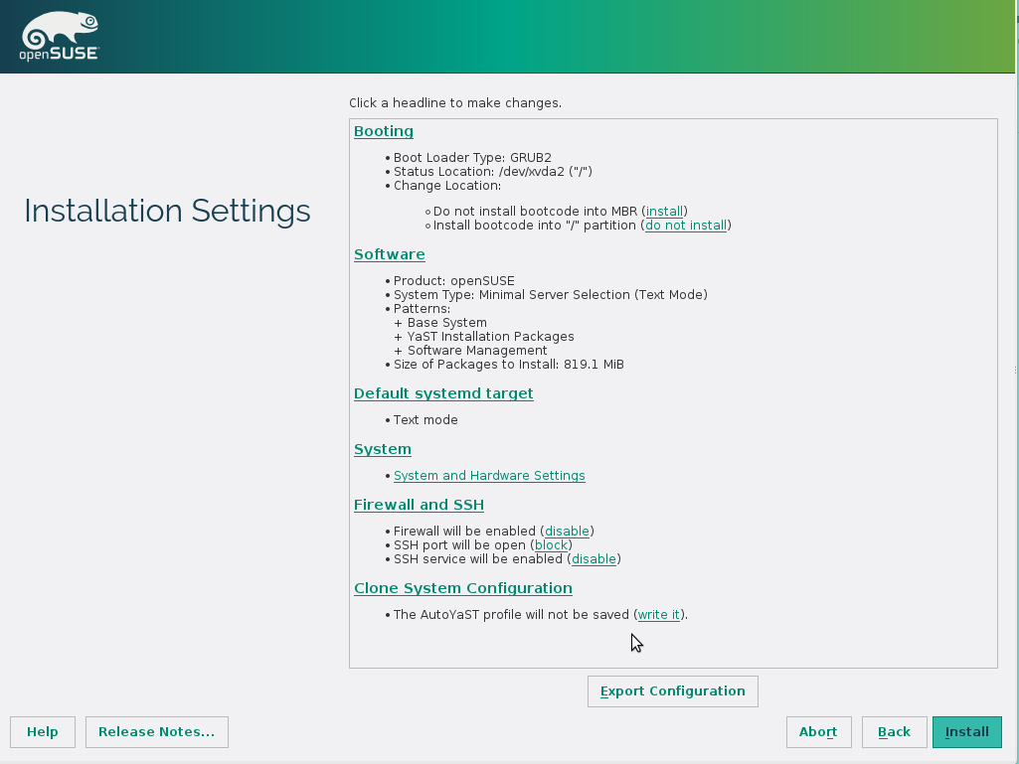

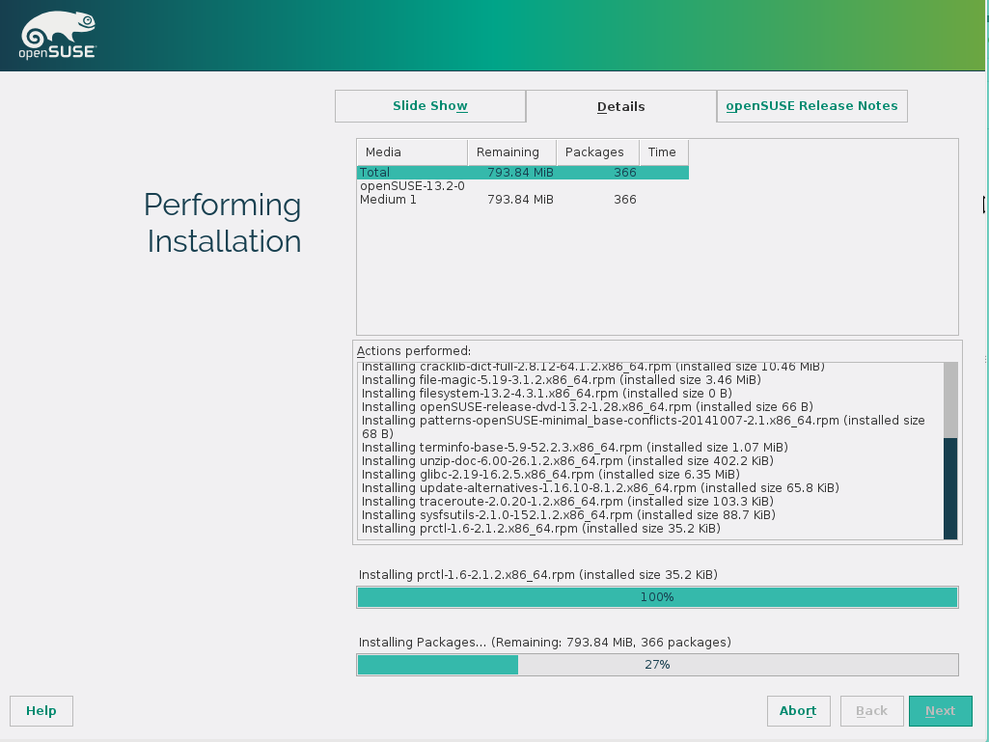

For VM we create X=9 GB system disk and Y=1 GB swap disk.
For HW servers we create 20 GB<X<100 GB system disk and Y=RAM/2 GB swap disk.
For logging we create an additional disk mounted on /media/logs (10 to 30 GB)

Thi first part of installation will be in graphical interface
  - In “Language” menu choose “English (US)”, “Layout - English (US)” then press Next ( ---@ Next)
  - Choose “New Installation”, untick "Use Automatic Configuration" ---@ Next
  - Set “Region” → Europe, “Time Zone” → Estonia ---@ "Next"
  - Choose “Desktop” → Other → Minimal server selection (Text Mode) ---@ Next
  - ---@ Create Partition setup”
    - “Hard Disk” → Custom partitioning ---@ "Next"
    - “System View” → Hard Disks → {DISK_NAME}
    - ---@ Expert → “Create new partition table” → MSDOS ---@ Yes
    - ---@Add → “New partition Type” → Primary partition ---@ Next
      - “New partition size” → Custom Size → X GB ---@ Next
      - “Formatting options” → File System ---@ Swap
      - “Mounting Options” → Mount Point = swap
      - ---@ Fstab options -> “Mount in /etc/fstab by” → Volume Label
      - In “Volume Label” enter (=) swap ---@ OK ---@ Finish
    - ---@Add → “New partition Type” → Primary partition ---@ Next
      - “New partition size” → Y GB ---@ Next
      - “Formatting options” → File System ---@ Ext4
      - ---@ Options → Directory index feature -> YES ---@ OK
      - “Mounting Options” → Mount Point = /
      - ---@ Fstab options -> “Mount in /etc/fstab by” → Volume Label
      - “Volume Label”= system
      - “No Access Time“ → YES ---@ OK ---@ Finish
    - ---@ Accept ---@ Next
  - “User's Full Name” = local, “Password” = !local1, “Automatic login” → NO ---@ "Next"
  - “Really use this password” ---@ Yes
  - “Firewall & SSH” → “SSH service ...” ---@ enable and open
  - ---@ Booting → “Boot loader” ---@ GRUB → Propose new .. ---@ OK ---@ OK
  - ---@Install ---@ Install

The second part of installation will be in text interface
  - “Hostname” = opensuse{VERSION}, “Domain Name” = template, “Change hostname via DHCP” → YES, “Assign Hostname to Loopback IP” → NO ---@ “Next”
  - “Network Configuration” → Use Following Configuration ---@ “Next”
  - “Test Internet connection” → No, Skip this test ---@ “Next”
  - Skip autorefresh & all updates
  - “Release notes” ---@ Next
  - “Installation completed” ---@ Finish

We need a small amount of customization
  - login as root
  - copy scripts to /etc/faster/cmdb
      - zypper --gpg-auto-import-keys --non-interactive in --no-recommends subversion
      - svn co --non-interactive --force https://svn.edss.ee/sys/cmdb --username faster --password faster
  - yast bootloader → delete unused kernels and set “xen kernel - DomU” as default for Xen DomU host and “openSUSE … (default)” kernel for others hypervisors
  - reboot linux

